17: Changing Hardware Compatibility of a VM Using VMware Workstation
1. Aim
To change the hardware compatibility of an existing Virtual Machine using VMware Workstation and execute basic UNIX commands.
2. Procedure
- Open VMware Workstation on the host computer.
- Select an existing Virtual Machine.
- Shut down the Virtual Machine.
- Click on VM → Manage → Change Hardware Compatibility (if available).
- Select the required VMware hardware compatibility version.
- Click Next and complete the configuration.
- Start the Virtual Machine and verify its working.
- Open the terminal inside the Linux operating system.
- Execute the following basic UNIX commands:
IMPLEMENTATION
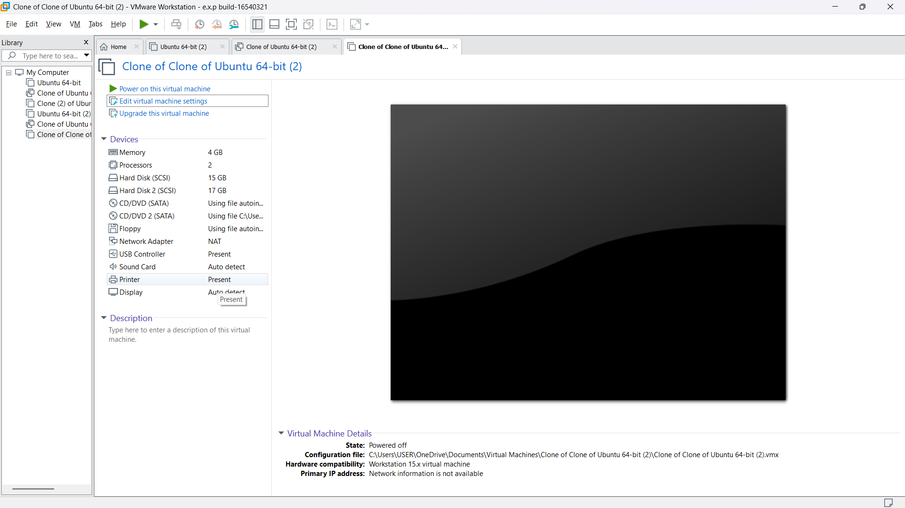
Result:Thus, the hardware compatibility of the Virtual Machine was successfully changed using VMware Workstation, and basic UNIX commands were executed successfully.

